50 Capital Cities (1)

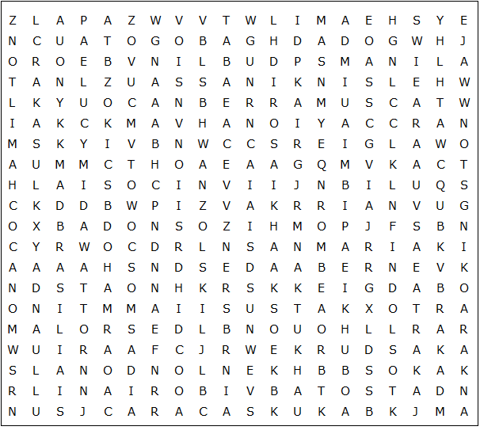

Brasilia Brussels Canberra Freetown Hamilton Helsinki

Kingston Kinshasa Monrovia Algiers Baghdad Bangkok

Beijing Caracas Colombo Jakarta Kampala Nairobi Nicosia

Ankara Athens Berlin Bogota Dublin Havana London

Luanda Lusaka Madrid Manila Monaco Moscow Muscat

Nassau Ottawa Accra Cairo Dakar Dhaka Hanoi Kabul

La Paz Minsk Baku Bern Doha Kyiv Lima Oslo Nuuk

50 Capital Cities (1)

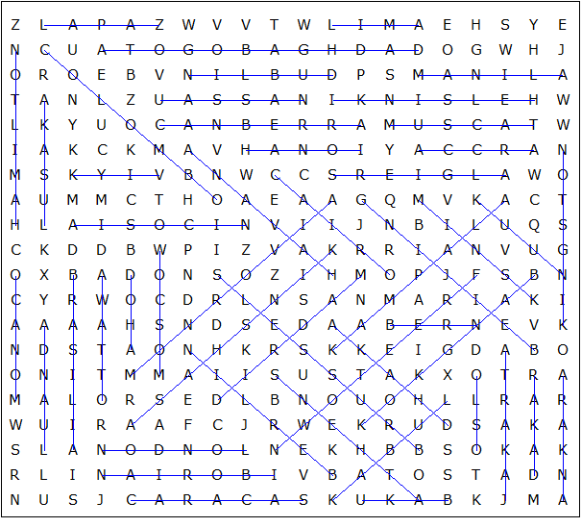

This puzzle was created in seconds using Toolbox, available for only £10 from discoveryeducationalsoftware.co.uk

